GIDDINGS & LEWIS
PiC Application Note

Document Number: AN000057

Topic: Circular Moves Using M_LINCIR and M_SCRVLC

The purpose of this application note is to provide an explanation and examples of using the M_LINCIR and M_SCRVLC function block. The difference between the function blocks is that the M_SCRVLC block applies an s-curve velocity profile. It is highly recommended that the M_SCRVLC function block be used to eliminate axis jerk. The examples include creating a square with rounded corners and creating circles in absolute and incremental mode.

Index:

Create a Square with Rounded Corners 2

Create a Circle in Absolute Mode 6

Create a Circle in Incremental Mode 9

M_SCRVLC Block Programming Tips 12

Revision History 14

Create a Square with Rounded Corners

This RndSqr.ldo example will be used to demonstrate creating a square with rounded corners. The M_LINCIR function block will be configured to start in the center of the top or back side of the polygon, move in a clockwise direction and complete the polygon with nine different segments as indicated in the figure below. The coordinates of each segment are also indicated on the figure below.

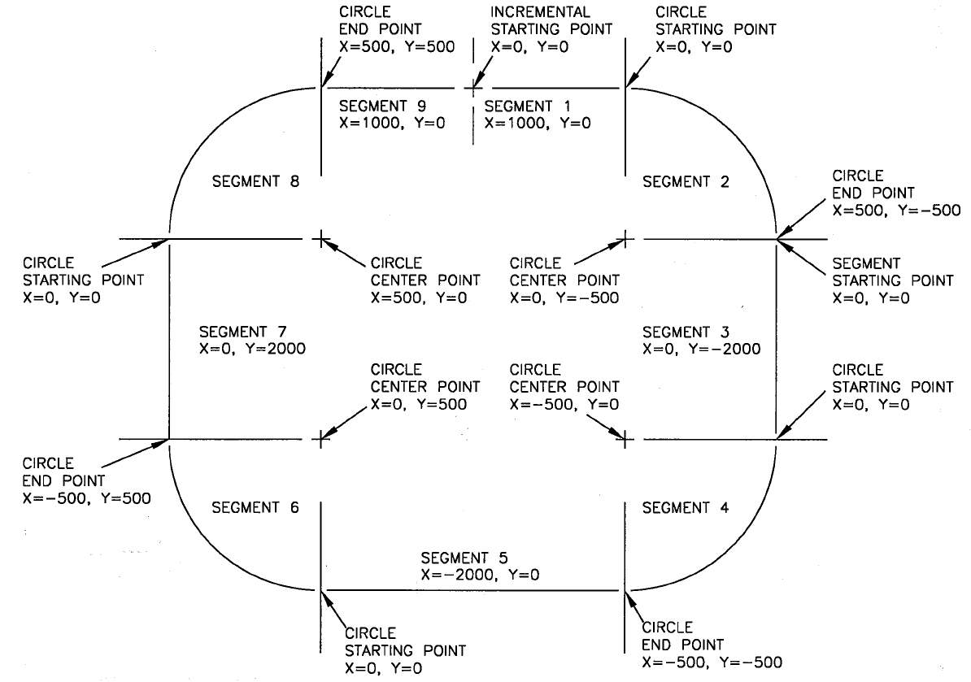
In this program the structure (MV) that is used to write values to the M_LINCIR block has 8 members.

Member Name Data Type Description
MTYPE USINT Move type: linear, CW circular, CCW circular
FD_TIME USINT Feed rate or time move
RATE DINT Rate (LU/min) or time (mS) value
ABS_INC WORD Mode absolute or incremental
X DINT End point for X axis
Y DINT End point for Y axis
X_CENTER DINT Center point for X axis
Y_CENTER DINT Center point for Y axis

In the software declarations table the structure values can be accessed for the nine segments of the polygon. The zero member for the NDPT input is not used by the M_LINCIR block although the array for it in this program is entered as ENDPT[0]. In any program the NDPT input must be entered in the form of XXXX[0].

The first segment or member 1 below is a linear type move at a rate of 30000 ladder units per min with both axes in incremental mode the x-axis will move a distance of 1000 ladder units and the y axis will move a distance of 0 ladder units from a starting point of (0,0).

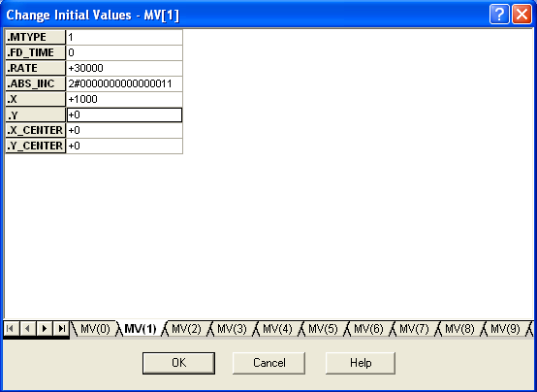
The second segment or member 2 below is a clockwise circular type move at a rate of 30000 ladder units per min with both axes in incremental mode the x-axis will move a distance of 500 ladder units and the y axis will move a distance of -500 ladder units from a starting point of (0,0) and around the circle center point of (0,-500).

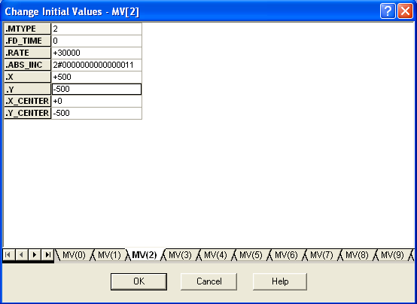

Each of the members has initial values to create the polygon. There is a pattern of a linear move, a circular move, a linear move, a circular move etc. Because the moves are all incremental and not absolute each segment or move uses a staring point of (0, 0). Incremental mode does not mean that the actual axis positions are set to zero. The starting point of (0, 0) is the reference for the start of the next move. If absolute mode was being used the starting point for the next move would be the actual position of the axes. The circle center point is determined from the starting point and is always incremental. Draw a line from the starting point of the circle to the center point of the circle and determine the coordinates of the center point. In this program the move type value of zero in the tenth member of the array is used to set the done bit.
Below is a table with the data segments used in the program (RndSqr.ldo) for creating a square with rounded corners.

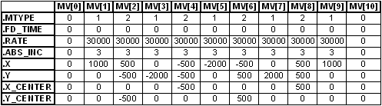

In the RndSqr.ldo program the structure (MV) is used to write values in the table above to the M_LINCIR block.

Refer to the M_SCRVLC block programming tips section of this document for information on ACCL, JERK, and MAXF parameters.
Create a Circle in Absolute Mode

The AbsCir.ldo example will be used to demonstrate creating a circle in the absolute mode. The M_SCRVLC function block is configured to start in the last position that the axes have been jogged, move in a clockwise direction at a rate of 30000 ladder units per minute around the CEN1 and CEN2 input values. Changing the CEN1 and CEN2 values will affect the diameter and the orientation of the circle. If the values of CEN1 and CEN2 were both at -500 ladder units the circle would be oriented in the 3rd quadrant relative to the starting point with a diameter of 1000 ladder units. If the values of CEN1 and CEN2 were both at 700 ladder units the circle would be oriented in the 1st quadrant relative to the starting point with a diameter of 1400 ladder units. The center of the circle is always an incremental distance from the starting point. When creating a complete circle the endpoints are always equal to the starting points.

The two networks in the ladder that provide this functionality are shown below:

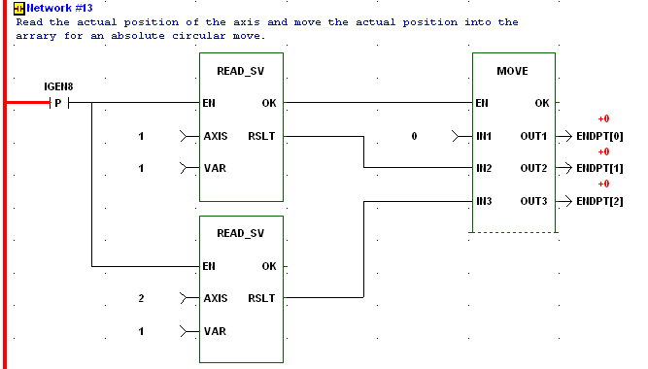

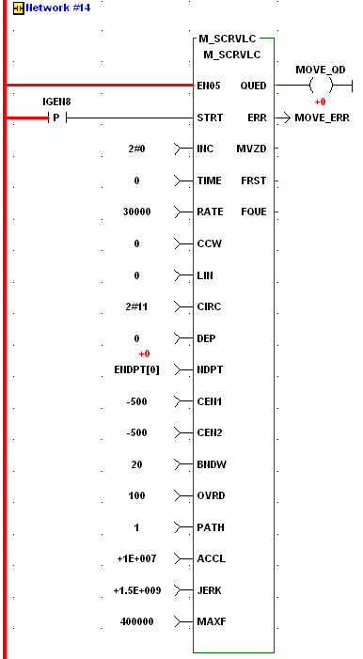

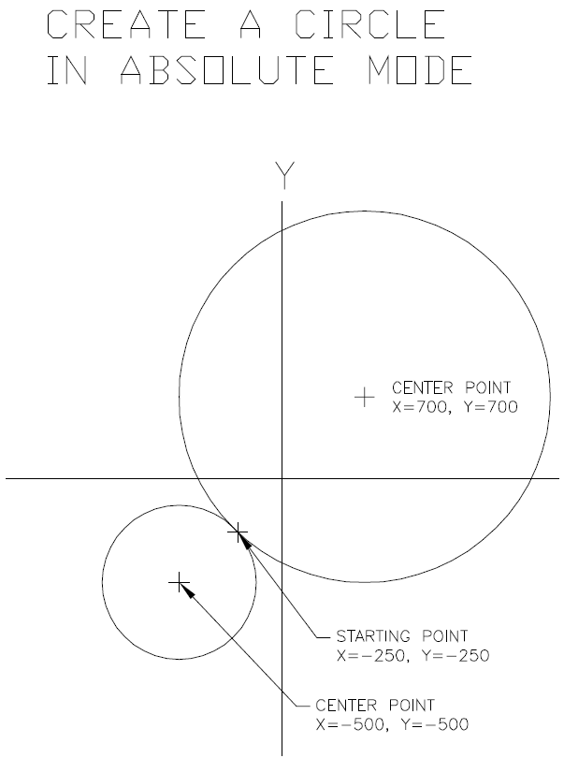
Create a Circle in Incremental Mode

The IncCir.ldo example will be used to demonstrate creating a circle in the incremental mode. The M_SCRVLC function block is configured to start in the last position that the axes have been jogged, move in a clockwise direction at a rate of 10000 milliseconds around the CEN1 and CEN2 input values. Changing the CEN1 and CEN2 values will affect the diameter and the orientation of the circle. If the values of CEN1 and CEN2 were both at -500 ladder units the circle would be oriented in the 3rd quadrant relative to the starting point with a diameter of 1000 ladder units. If the values of CEN1 and CEN2 were both at 700 ladder units the circle would be oriented in the 1st quadrant relative to the starting point with a diameter of 1400 ladder units. The center of the circle is always an incremental distance from the starting point. Incremental mode treats the starting points as (0, 0). To create a complete circle the end points will be (0, 0). A partial circle would require calculating the end points in relation to the start points. If a half circle is desired in the examples above the ENDPT[1] and ENDPT[2] for the circle would be set to -1000 and 1400 respectively.

The two networks in the ladder that provide this functionality are shown below:

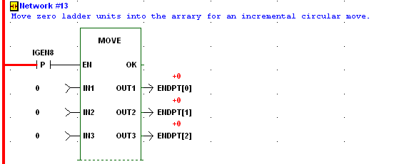

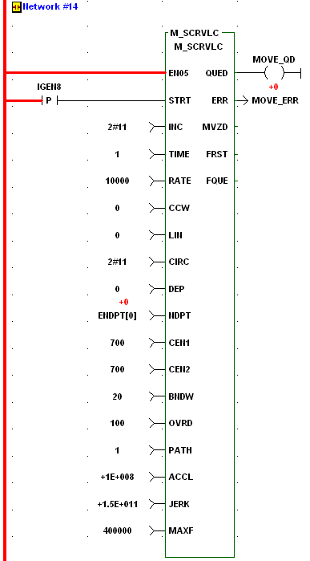

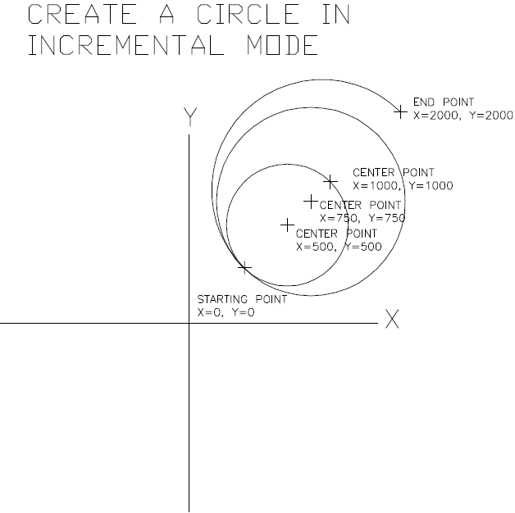
M_SCRVLC Block Programming Tips

The feedrate override percentage OVRD input is usually set to 100 percent for the machine to run at the RATE input.

Typically the time axes are in the servo set up as shown below. The time axis determines the PATH input to the M_SCRVLC block. The relationship is that time axis 25 would have a path input of one, time axis 26 would have a path axis of two, time axis 27 would have a path axis of three, and time axis 28 would have a path axis of four.

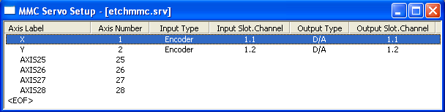

The table below provides recommended values for the ACCL and JERK inputs to the M_SCRVLC block. The table and an explanation of the SCURVE function that is used inside the M_SCRVLC block can be found in the PicPro Function Block Guide.

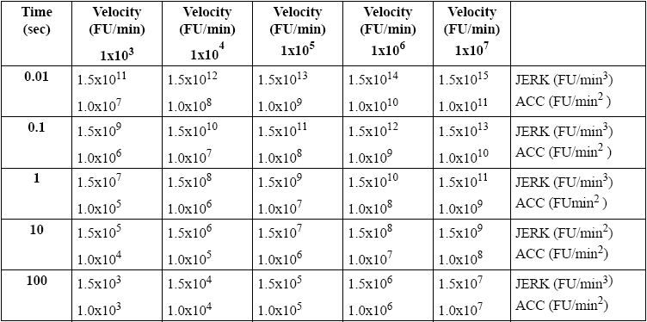
The MAXF input to the M_SCRVLC block would be the lowest velocity limit value for the axes that are being slaved by the time axis. The velocity limit values are in the servo set up file as shown below. This can be accessed by opening the servo set up double click on an axis select axis data and iterator data.

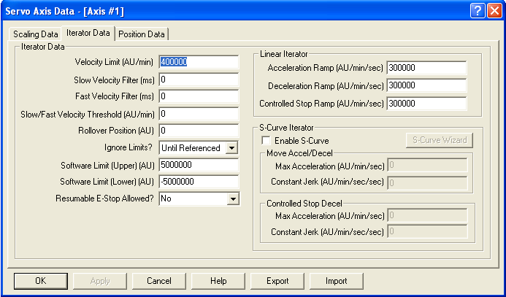

The example programs RndSqr.ldo, AbsCir.ldo, and IncCir.ldo for this application note are in the following folder:
C:\G&L Motion Control Data\Applications V16.1.2\Examples\M_LINCIR-M_SCRVLC Application Note 57

The software and hardware used to demonstrate the moves in this application note are as follows:

Software: PicPro Professional Edition Version 16.0 Service Pack 2
Hardware: Stand Alone Analog MMC
Etch A Sketch Demo Unit

Revision History

Date: May 13, 2008
Author: Alan Geiger
Changes: Original

Date: [For each revision, enter the date revised,]
Author: [the name of the person revising the document,]
Changes: [and indicate what changes were made.]

